Name: Sapargali Temirlan
Group: SE-2403
Instructor: Kozhakhmet Zhaksylyk
Assignment 4
Deriverables
All deliverables such as the contract files and e.t.c, are inside same directory as this document.
Test suite:
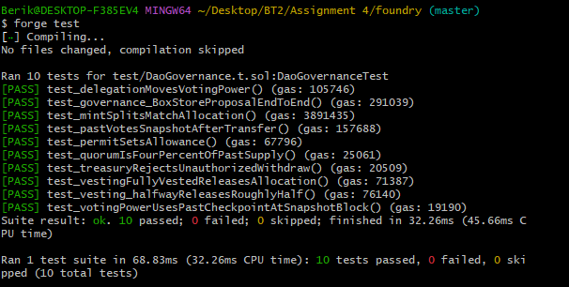
Deployment:
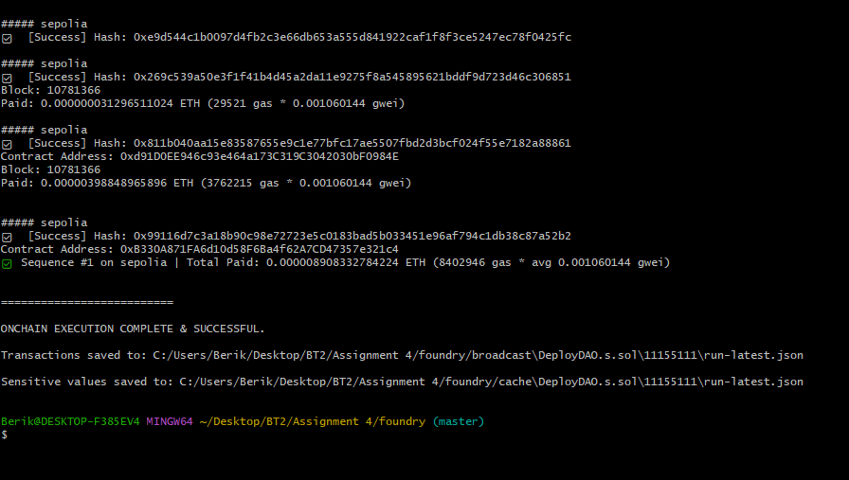

UI:
